

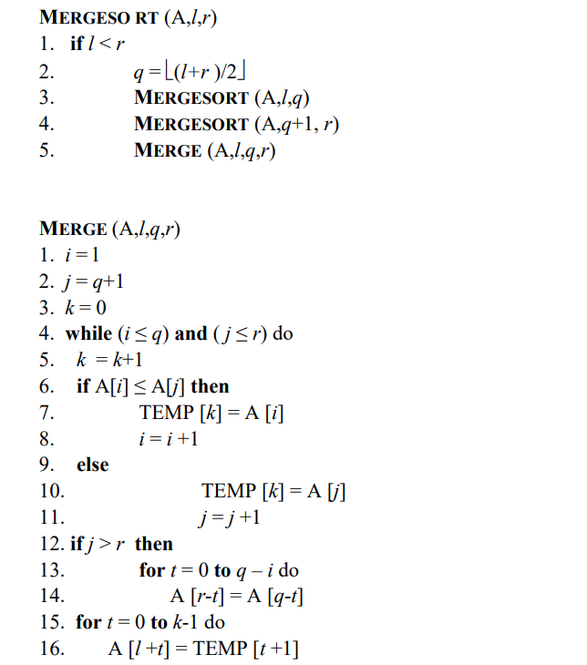

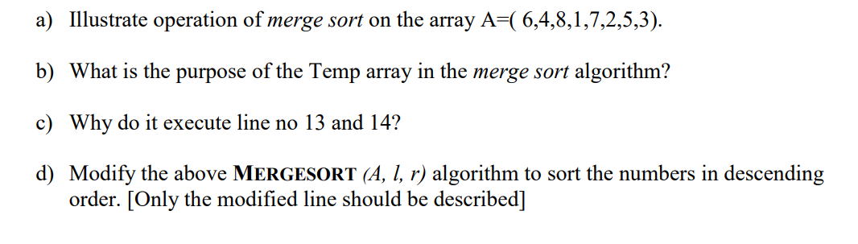

Should illustrate this operation till the 2 arrays are full

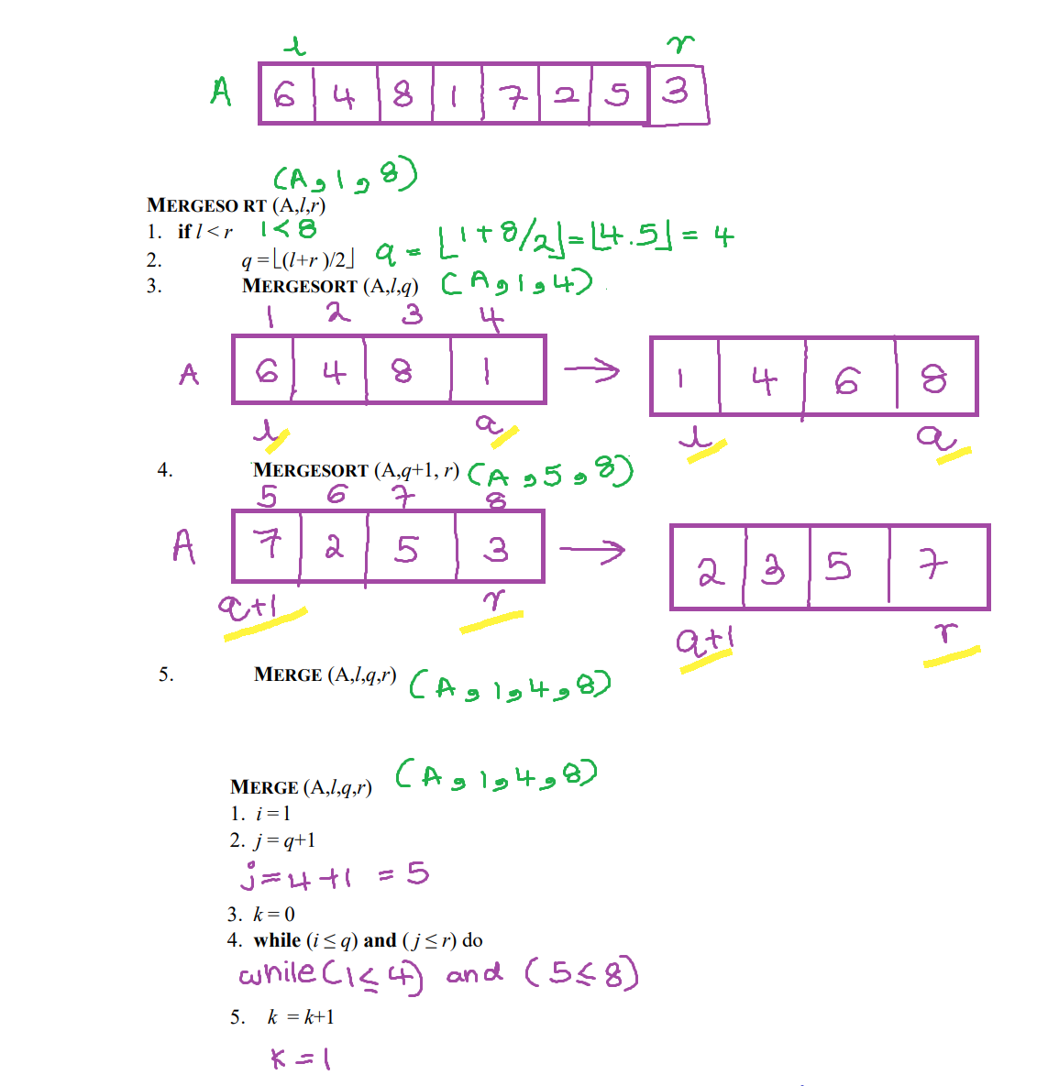

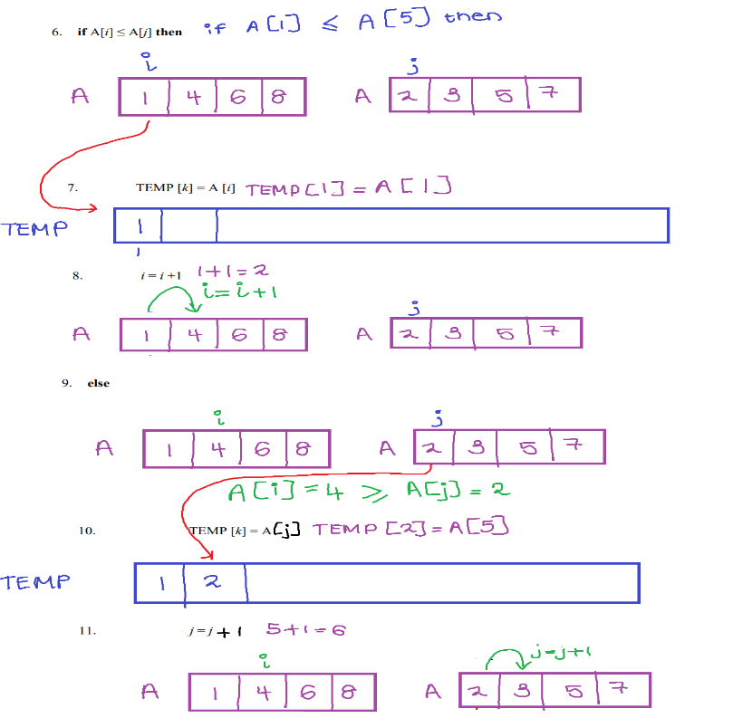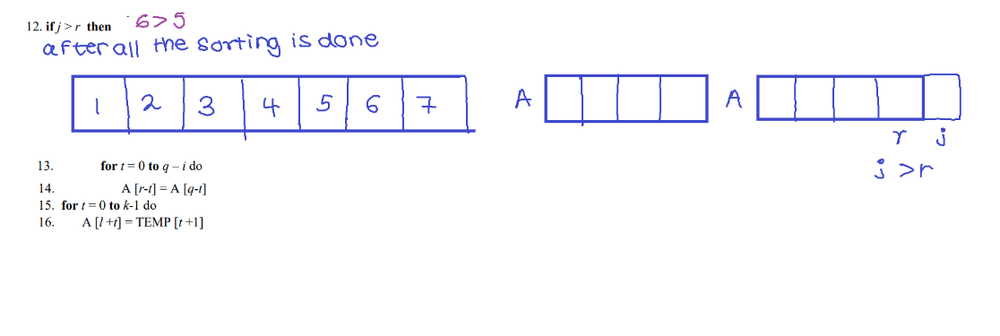

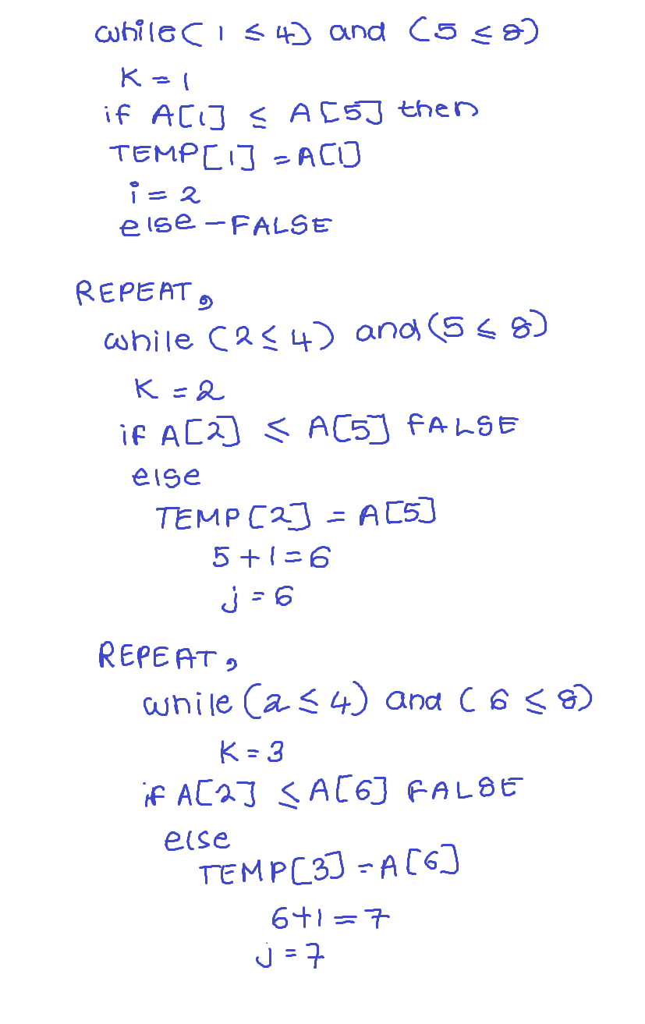 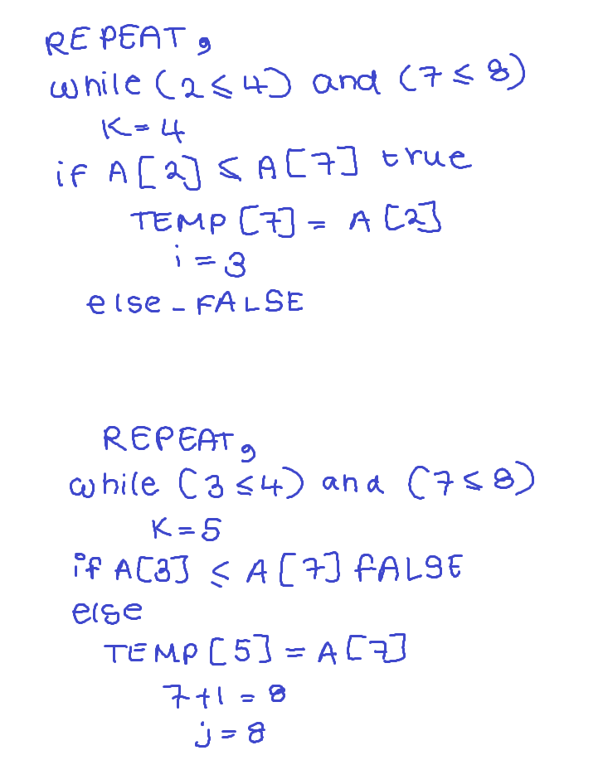

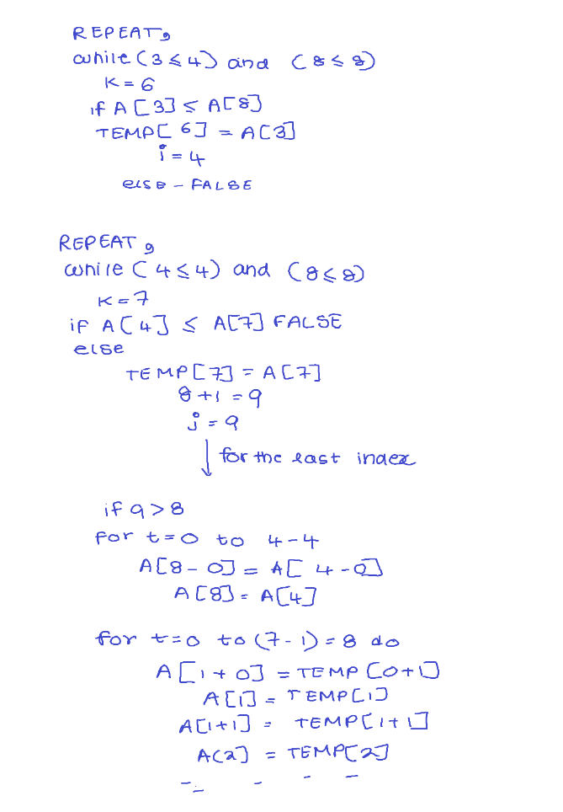

1. The purpose of TEMP array is to have a fresh array of elements or else if we use array A for this process the sorted elements would get mixed up with the unsorted elements

Therefore to avoid overwriting we use TEMP

1. At the end in this case although the right sub array finishes sorting, there are elements left in the left sub array. The values in left sub array is greater than the values of right sub array. Therefore the lines 13 and 14 are to place the elements left in the left sub array in the right place
2. In order to arrange from descending to ascending order we need to change line number 16 to

If A[i]>= A[j] then



